Quarch Technology Ltd

AN-024

Application Note

HD PPM Pattern Example

For use with:
HD Power Modules

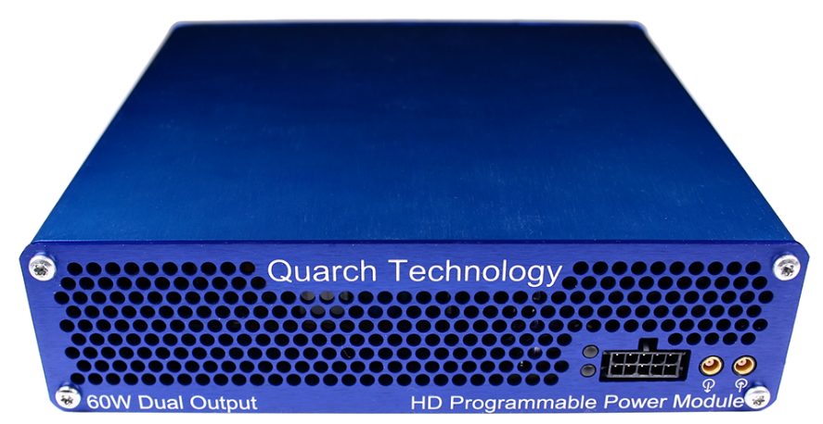

Change History
1.0 |  | Initial Release
1.1 | November 2022 | Fixed python warning

Contents
Change History 2
Introduction 4
Modules Supported 5
System Supported 5
Application Note Example Files 5
Installation and setup 5
Python install 5
https://docs.python.org/3/using/windows.html#excursus-setting-environment-variables 5
QuarchPy library install 6
Power module setup 8
Running the example 9

Introduction
The pattern generator in our PPM (Programmable Power Modules) is a very useful feature which can create a huge range of power test cases:
- Ramps
- Glitches
- Power loss
- Brownout
- Ripple
Here we show how to create a pattern using a script. In this case we will create a ‘chirp’ on the rail. This can be increased in magnitude until a drive failure is detected.

Modules Supported
HD power modules
- QTL1995
- QTL1999
XLC power modules (Supports this feature, but not specifically tested with this note)
- QTL1824
- QTL1847

System Supported
This example is written and tested on Windows, though could be used on Linux and MacOS. It currently requires Python 3.x

Application Note Example Files
The AN-024.zip should be extracted to your preferred location.
PatternExample.py | Main python file to execute

Installation and setup

Python install
If you do not already have Python 3.x installed, download and install it from:
https://www.python.org/downloads/
Under Windows it is helpful to make sure the Python installation directory and PythonXX\Scripts are included in the PATH environment variable. See:
https://docs.python.org/3/using/windows.html#excursus-setting-environment-variables

QuarchPy library install
The Quarch Python package can be installed from the Python web repository (assuming you have internet access) or via the download from our website.
Quarchpy will also install a version of Quarch Power Studio

Web Install
From the command line:
>pip install quarchpy
If this fails, your path to “pip” may not be set, you can instead run:
>python –m pip install quarchpy

Local Install
If you want to install from a downloaded folder, ensure the folder is unzipped to a local disk, navigate to the folder containing the setup.py file and run (noting the ‘.’ on the end):
>pip install quarchpy .
If this fails, your path to ‘pip’ may not be set, you can instead run:
>python –m pip install quarchpy .

Upgrade
If you already have QuarchPy installed, you will get a failure message. If you want to upgrade to a new version, you need to add the ‘--upgrade’ command:
>pip install --upgrade quarchpy
The --upgrade command can similarly be used in any of the other examples, to load from a local install folder.

Power module setup
Connect the power module to the test PC and the output of the power module to the drive under test.

Customer Drive
USB/LAN Connection
Power Module
Customer Test PC

Running the example
Execute the script and the pattern will be sent to the device and run. A simple loop modifies the pattern each time, to increase the magnitude of the ripple.
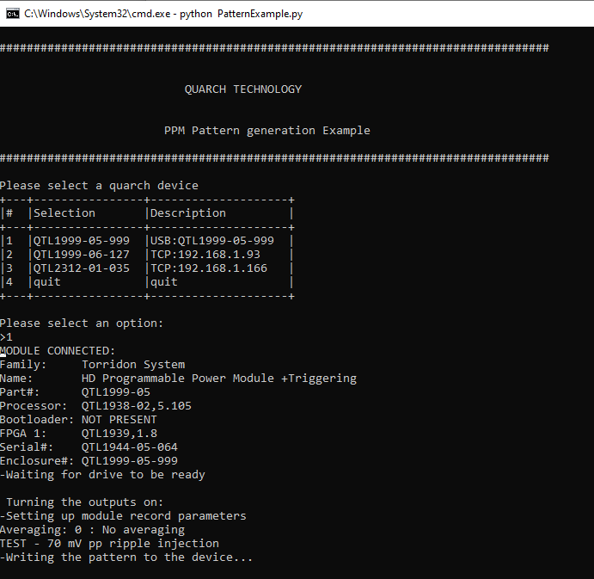

Here is an example of the pattern when opened in Quarch Power Studio.
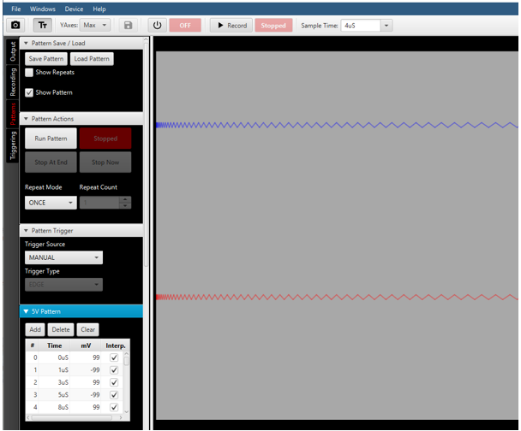
The example script just creates the pattern and runs it, but you could easily add in your own code to verify that the drive handled each run of the pattern as expected.

